1. Overview
Project Name: TBD
Ultimate Goal:
Create some form of centralized feed that gathers financial data / trends in real time.

Key Features: (brain storming rn)
- Gather data through sources like X, (maybe kalshi) (in real time) (
  - Other potential data sources can be from videos / podcasts from certain people
  - Maybe track tweets from certain people
  - (hashtags)
  - Have a fyp
- Use a classifier model like jev
- Redis cache to store:
  - Recent stock trends
  - Market data
- Allow users to search about certain feature and maybe have some sort of RAG system
  - Examples:
    - User inputs: “give me recent data involving Nvidia”
- Maybe allow user to have alerts? (this could be good use of adding pub sub feature)
- Audio features
- MCP Server
  - (ex: voice → text → Action)
  - Keep an alert of blah blah blah
- General consensus
  - EVERYONE is talking about something
    - Oh we see a spike in this maybe u should look into it
- Track all reddit posts on WSB → spike in some stock
  - Everyone talking about micron before it booms
Solana API Use cases:
- Cool stuff: using solana for games (
- Agent wallets + payments (https://www.lobster.cash/)
Resources:
https://www.mlh.com/partners/solana https://solana.com/skills?utm_source=mlh&utm_medium=referral&utm_content=Solana+Agent+Skills

Polymarket:
- All users / trades are public
  - Track whale trades → notification to keep track of incoming news
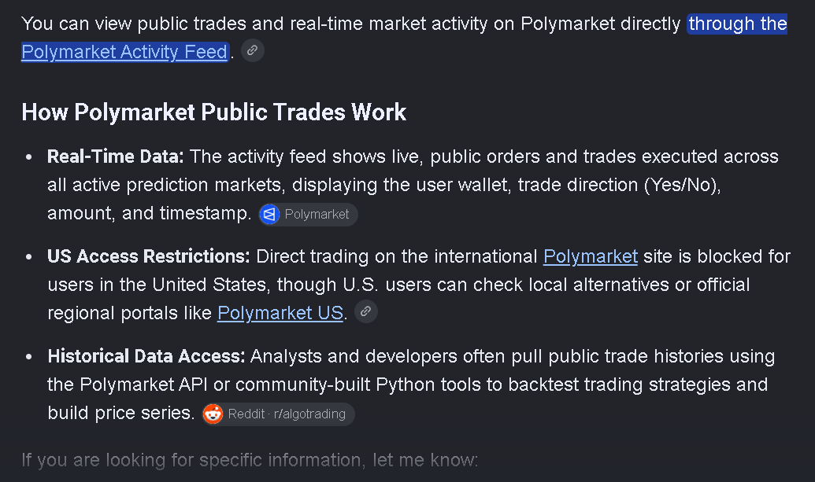

- Track relations between companies
  - EX: Tesla expanding self driving
    - Company that supplies LIDR may go up

- Paper Trade (alpaca / solana)

paper_buy (TICKER / CRYPTO, AMOUNT, …)

